CLMS SOFTWARE

EIC Master:

*Engineer master records with their status. You can add, edit particular records and can export all records in excel sheet.*

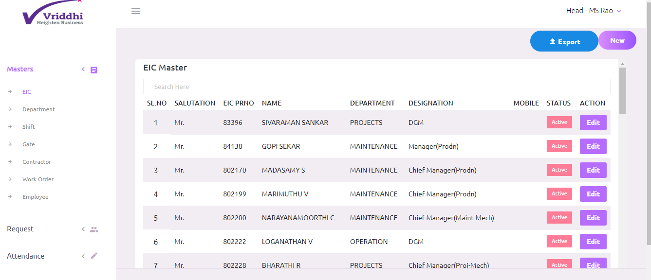

Department Master:

*Department master records with their status. You can add, edit particular records and can export all records in excel sheet.*

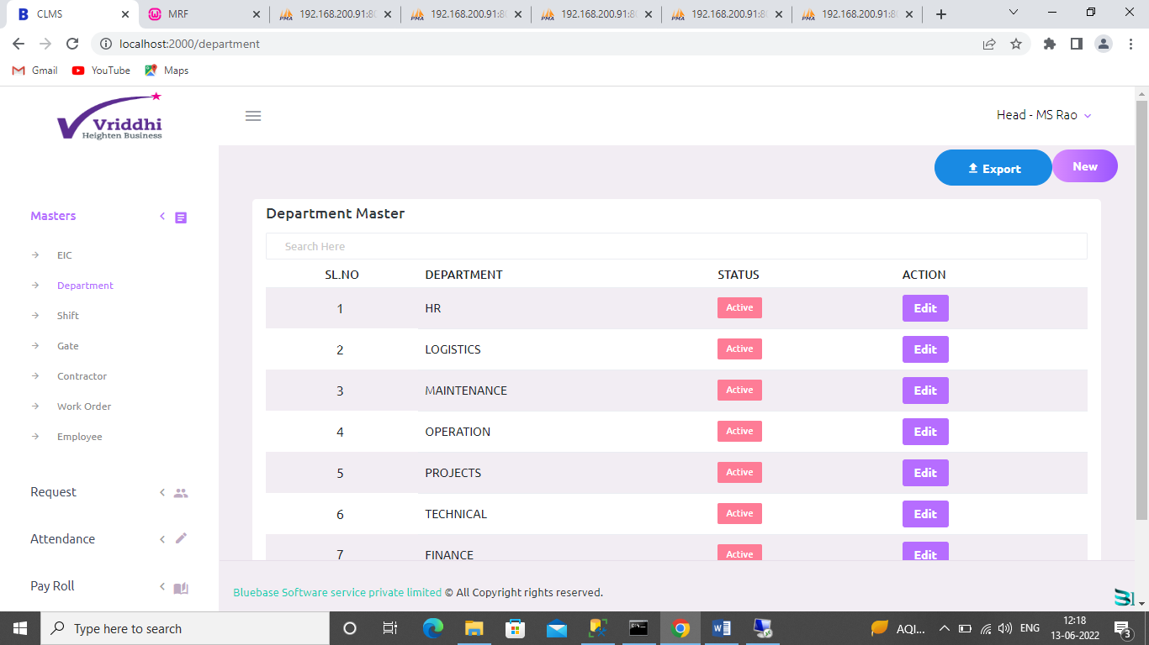

Shift Master:

*Shift master records with their status. You can add, edit particular records and can export all records in excel sheet.*

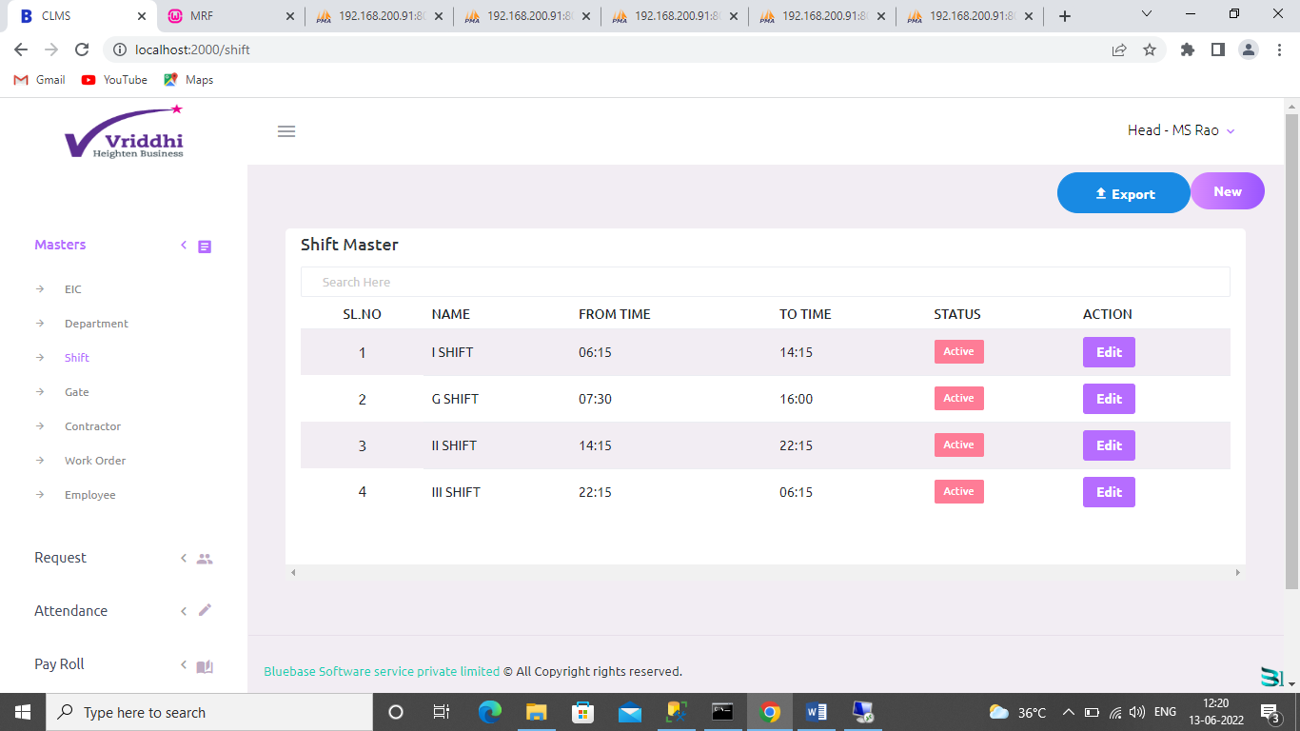

Gate Master:

*Gate master records with their status. You can add, edit particular records and can export all records in excel sheet.*

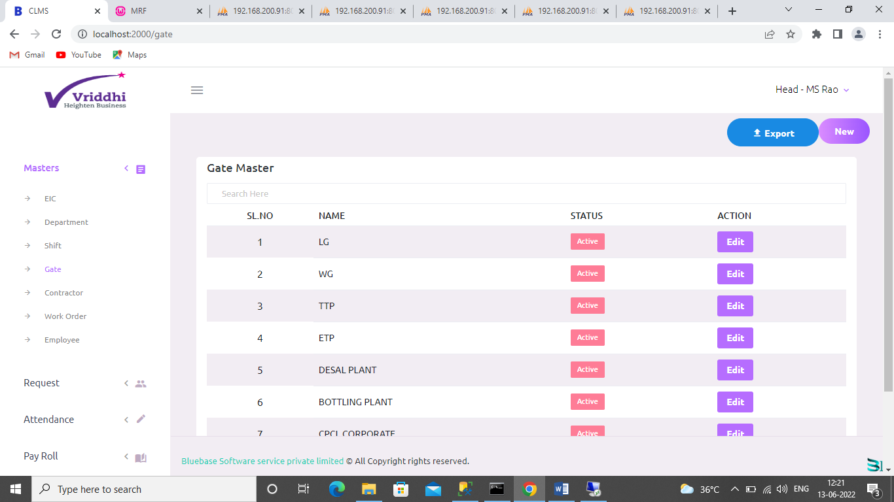

Contractor Master:

*Contractor master records with their status. You can add, edit particular records and can export all records in excel sheet.*

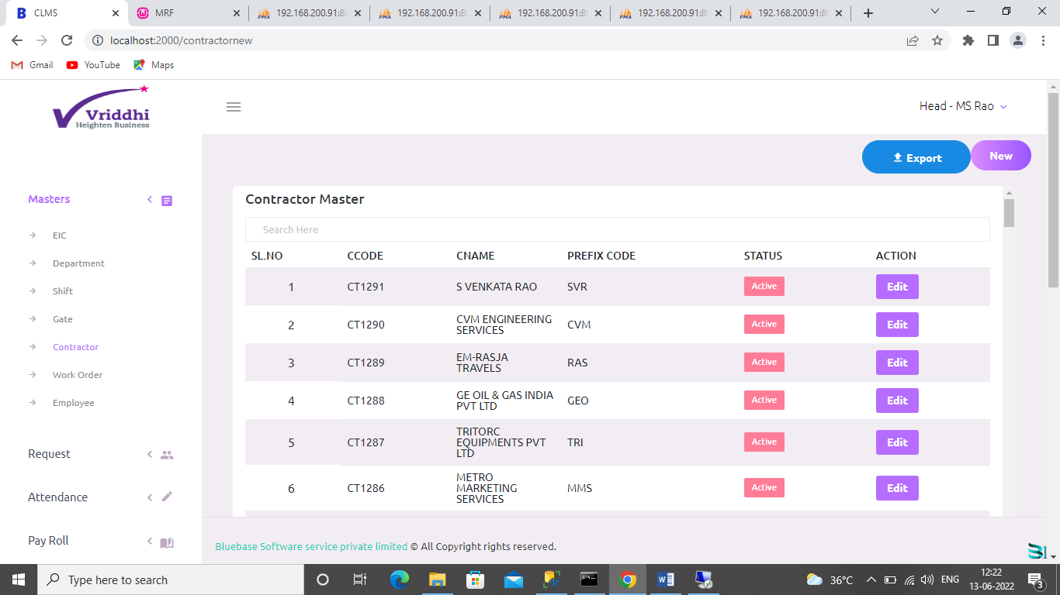

Work Order Master:

*Work order master records with their status. You can add, edit particular records and can export all records in excel sheet.*

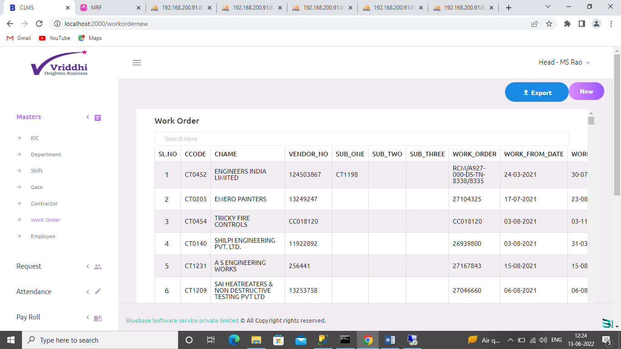

Request Transfer :

*This is the transfer list of employees from one work order to the other.*

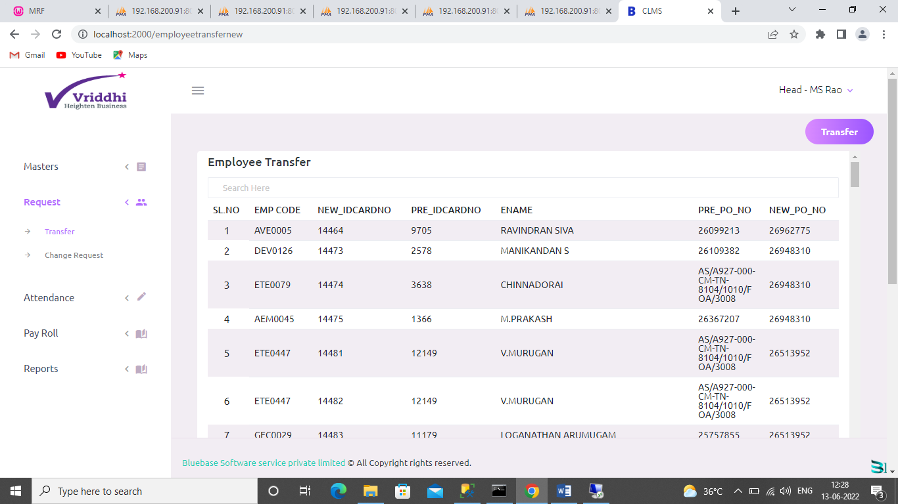

Here is the employee where transferred from one work order to other Work order.

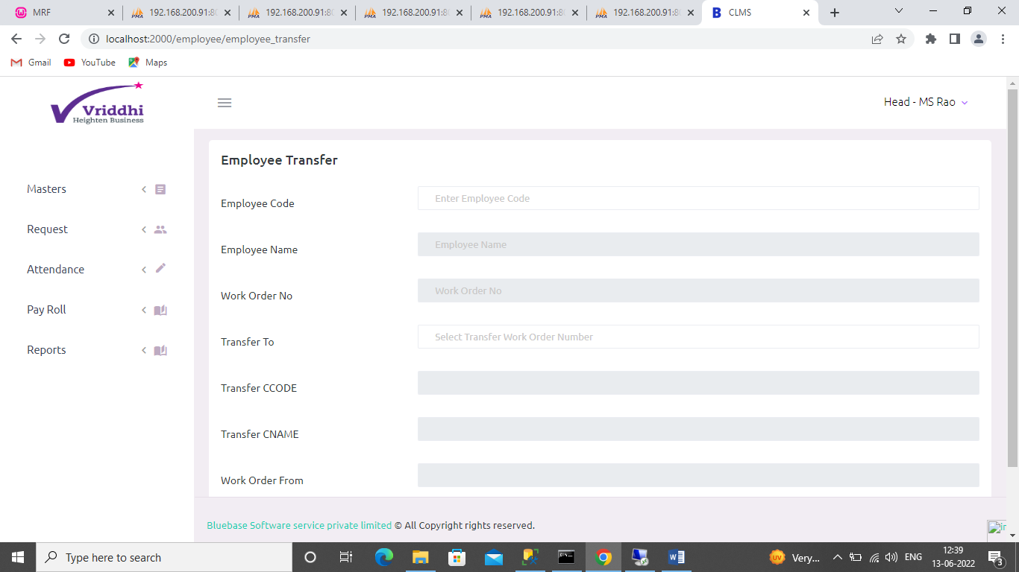

Attendance In-Out :

This is the attendance report of given contractor with from date and to date.

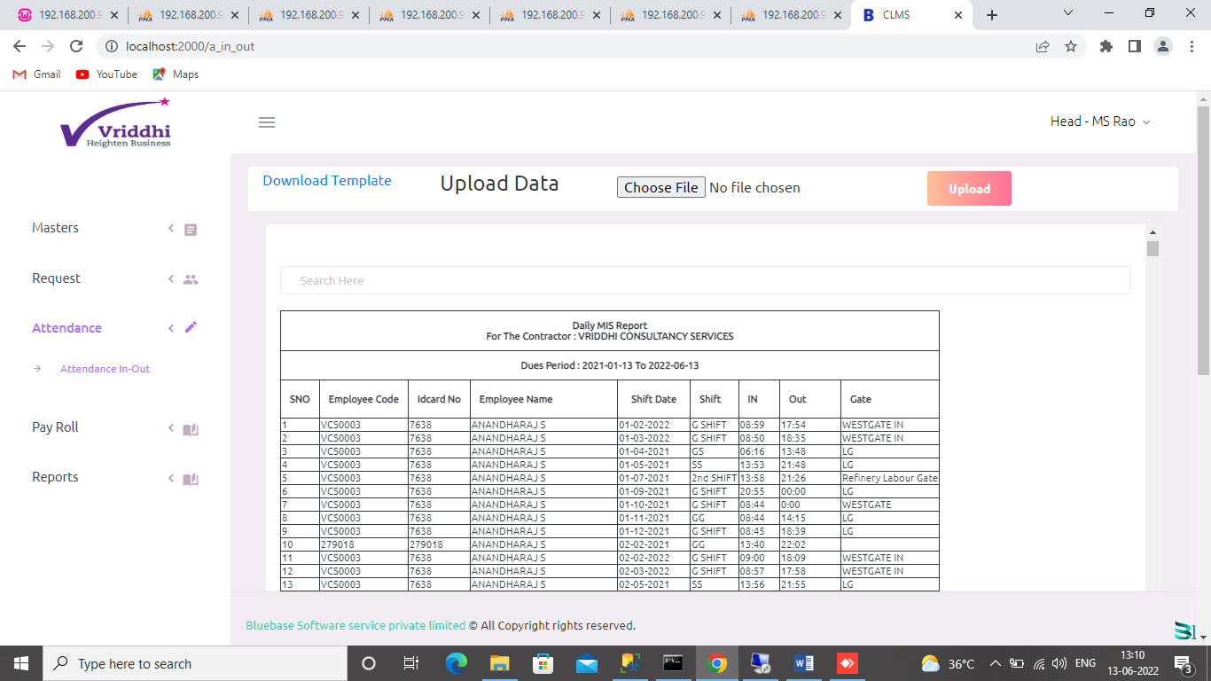

**Payroll generation:**

This menu is used to generate payroll.

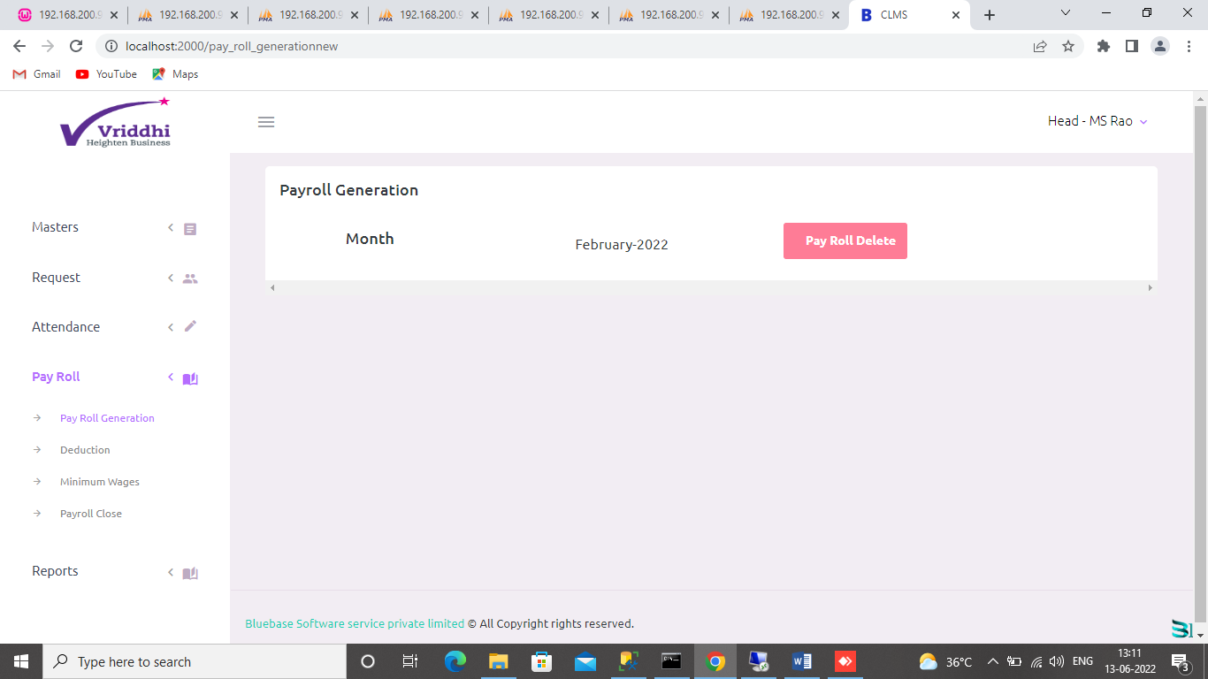

**Deduction:**

This is the deduction list where you can add,take print and export in excel.

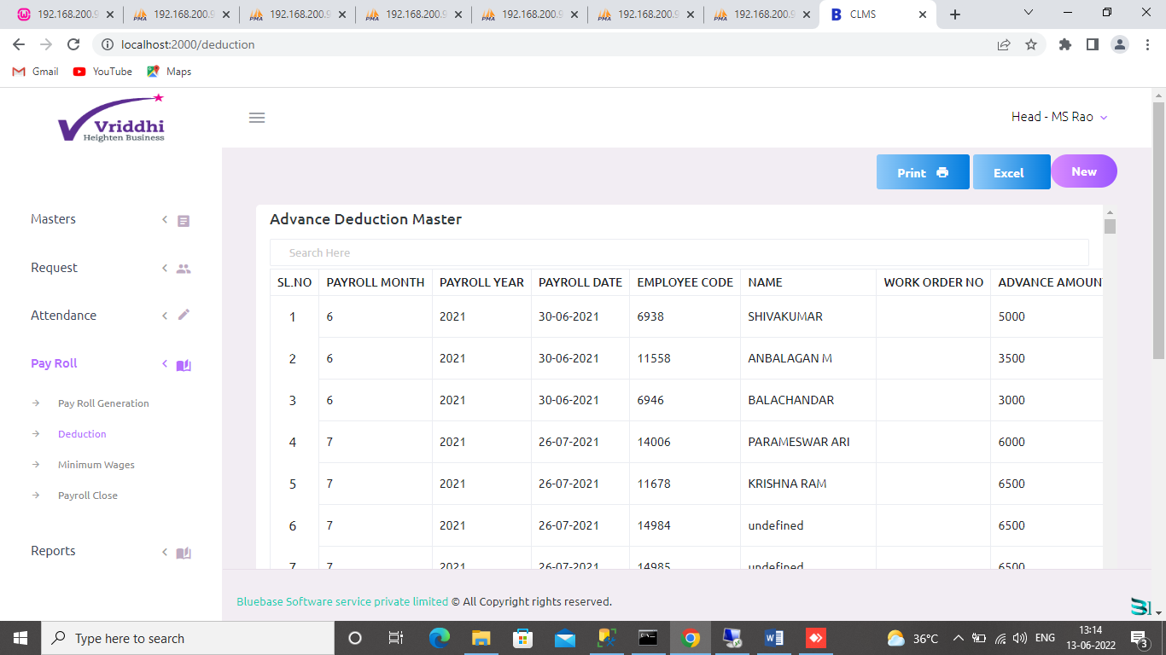

**Payroll Close:**

Here you can close the payroll.

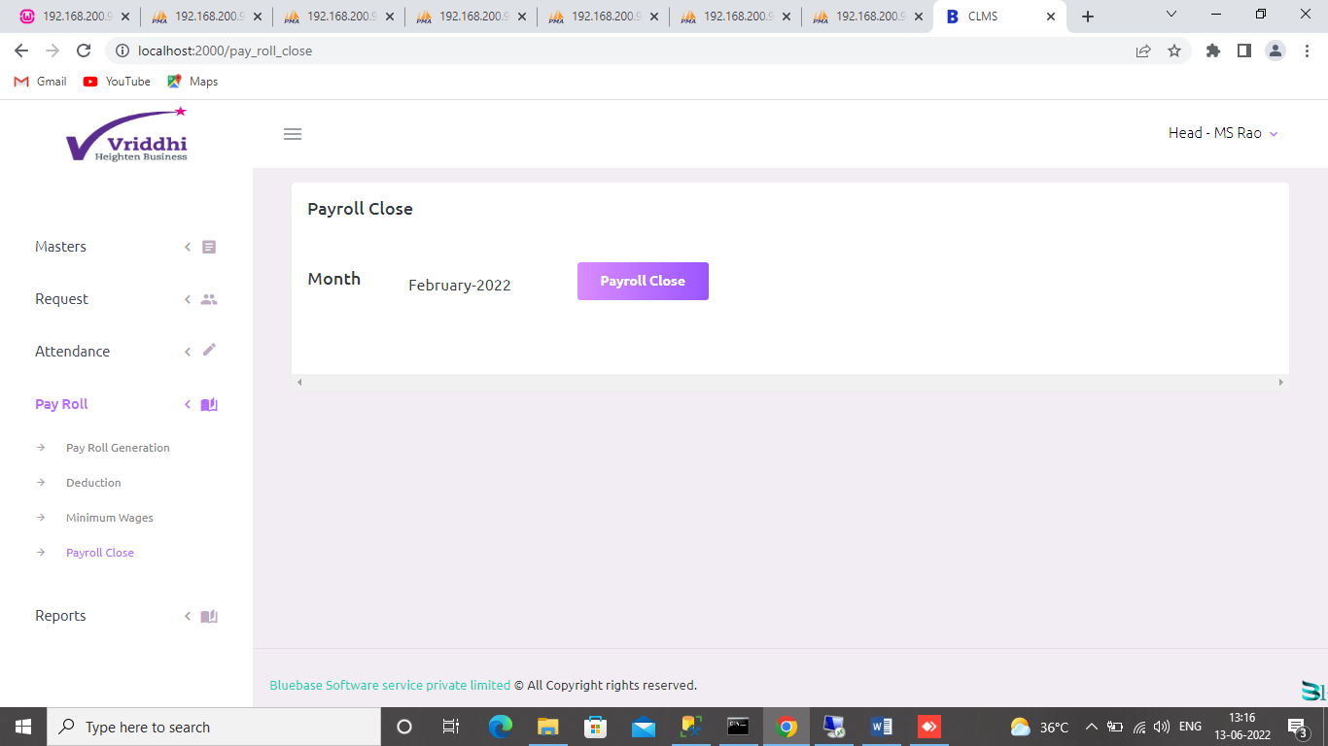

**Wage slip 1 Report:**

This is the report for wage slip 1.

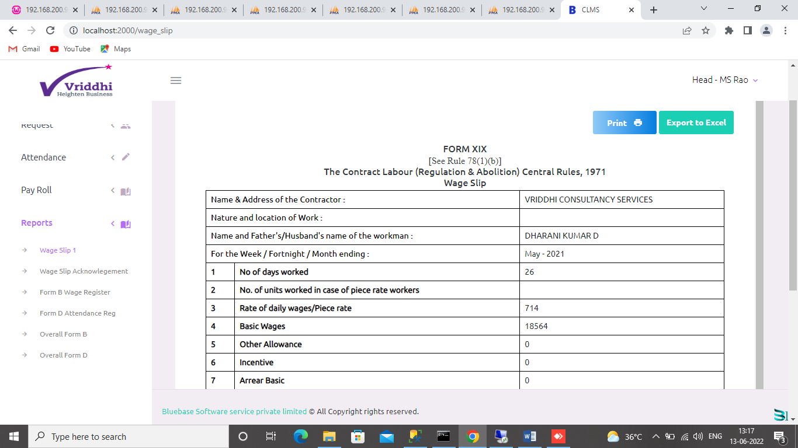

**Wage slip Acknowledgement Report:**

This is the wage slip acknowledgement report and you can take print and export the report.



**Wage slip 2:**

This is the wage slip 2 report and you can take print and export the report.

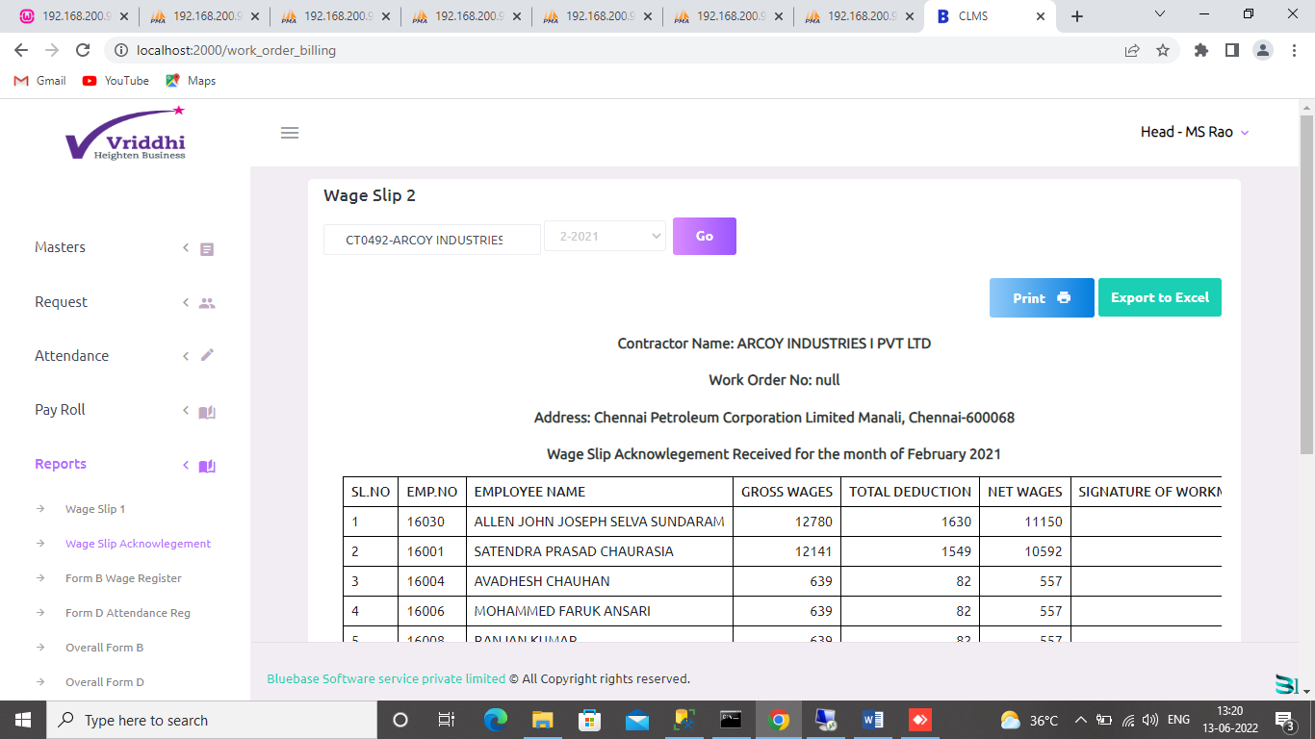

**Form B Wage Register:**

This is the form B wage register. You can take print and export to excel.

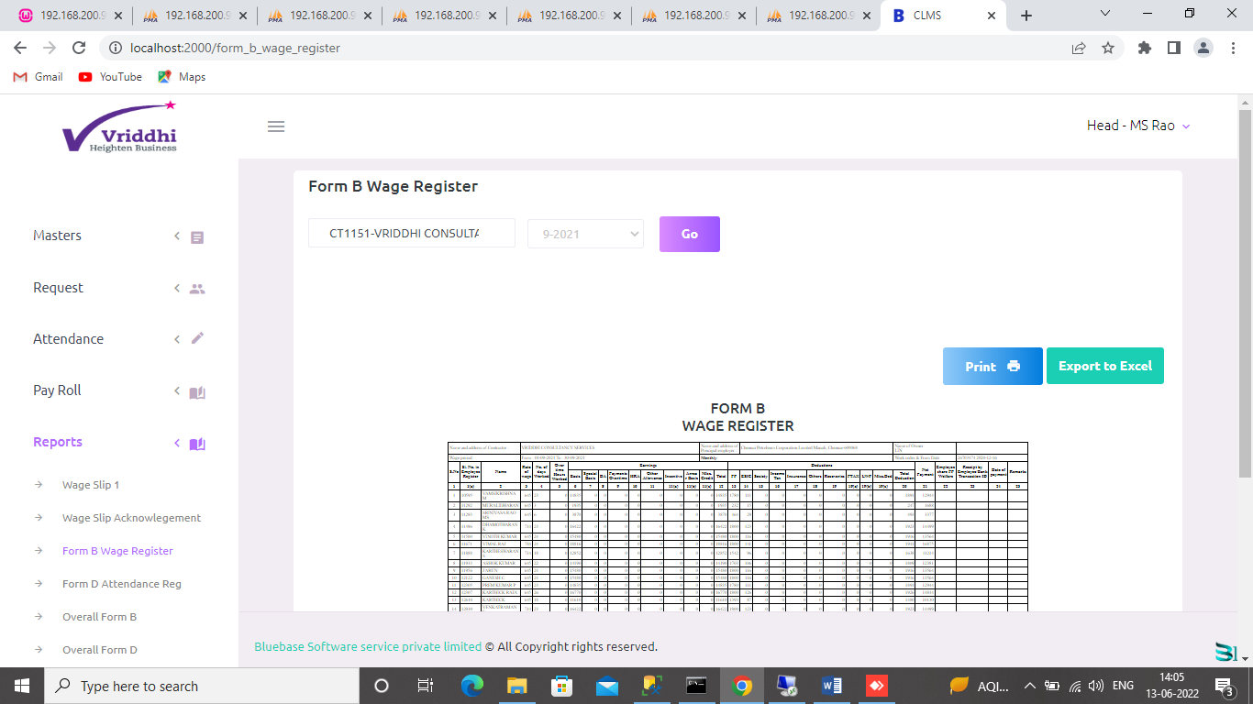

**Form D wage register:**

This is the form D wage register. You can take print and export to excel.

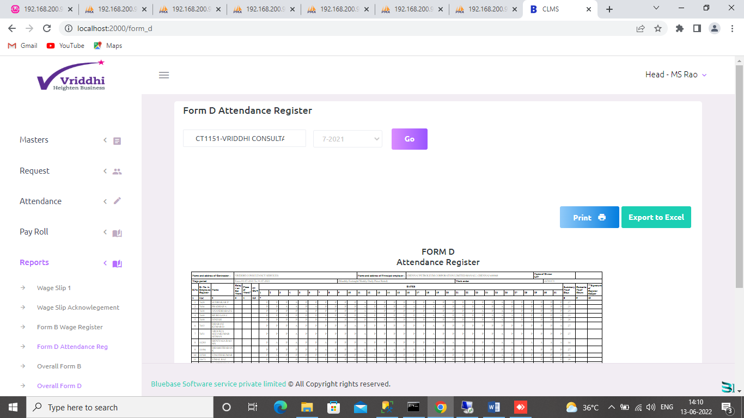

**Overall Form B:**

This is the overall form B report for all the contractor of given month.

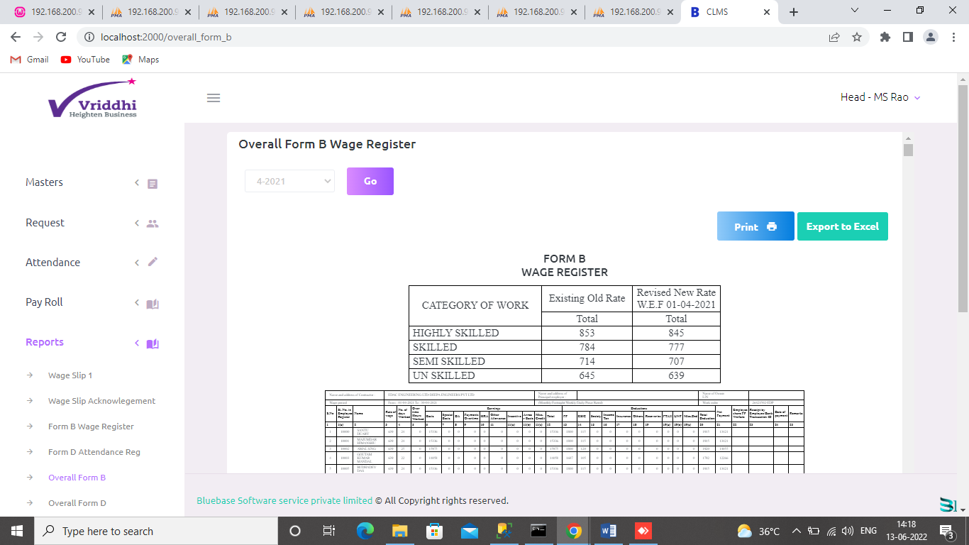  
Overall Form D:

This is the overall form D report for all the contractor of given month.

